ASSESSMENT-4
C. Pavani (192524260) CSA1006-SOFTWARE ENGINEERING

Software Testing, CI/CD, Docker, and Application Monitoring

1. Mutation Testing and Fuzz Testing

Mutation Testing
Mutation Testing is a software testing technique used to check the effectiveness of existing test cases. In this technique, small changes called mutations are intentionally introduced into the program code.
Example:
Original code: if (age >= 18)
Mutated code: if (age > 18)
If the existing test cases detect this change and fail, the mutation is killed. If the tests still pass, the mutation survives, indicating that the test cases may be weak.
Benefits:
- Measures the quality of test cases.
- Identifies missing test conditions.
- Improves test coverage.
- Helps developers create stronger test cases.
- Increases software reliability.

Fuzz Testing
Fuzz Testing (Fuzzing) is a testing technique in which large amounts of unexpected, random, malformed, or invalid input are provided to a software application.
Examples of fuzz inputs:
- Very large input
- Empty input
- Random symbols
- Special characters
- Malformed data
The purpose is to discover crashes, errors, vulnerabilities, memory problems, and unexpected behavior.
Benefits:
- Detects security vulnerabilities.
- Finds crashes and unexpected failures.
- Tests input validation.
- Helps identify buffer overflow and injection-related problems.
- Improves robustness against malicious or unexpected inputs.

How Mutation Testing and Fuzz Testing Improve Reliability and Security
Technique | Main Purpose | Improvement
Mutation Testing | Tests the quality of test cases | Improves reliability
Fuzz Testing | Tests software with unexpected inputs | Improves reliability and security

FLOW CHART
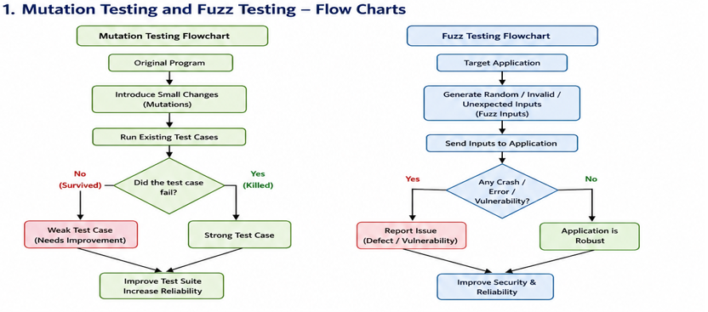

Conclusion: Mutation Testing ensures that the tests themselves are strong, while Fuzz Testing ensures that the software can handle unexpected and potentially malicious inputs. Together, they improve software quality, reliability, robustness, and security.

2. Key Stages of a CI/CD Pipeline
CI/CD stands for Continuous Integration and Continuous Delivery/Deployment. It automates the process of building, testing, and delivering software.

1. Source Code Management
Developers write code and push it to a Git repository such as GitHub.

2. Build
The CI/CD tool automatically downloads dependencies and builds the application.

3. Automated Testing
Automated unit tests, integration tests, and other tests are executed. If tests fail, the pipeline stops and developers are notified.

4. Code Quality and Security Checks
Tools check code quality, vulnerabilities, dependencies, and coding standards.

5. Package/Artifact Creation
The application is packaged into a deployable artifact, such as a JAR file, executable, or Docker image.

6. Deployment to Staging
The application is deployed to a staging environment for additional testing.

7. Production Deployment
After successful validation, the application is deployed to the production environment.

8. Monitoring and Feedback
The deployed application is monitored for errors, performance, and availability.
CI/CD Flow:
Code Commit → Build → Automated Tests → Security & Quality Checks → Package / Docker Image → Staging → Production → Monitoring → Feedback

How Docker Supports Continuous Delivery
Docker packages an application together with its dependencies and configuration into a container.
Application + Libraries + Dependencies + Configuration → Docker Image → Docker Container
Docker supports continuous delivery because:
- Consistent environment: The same container can run in development, testing, staging, and production.
- Easy deployment: Docker images can be built automatically by the CI/CD pipeline.
- Faster delivery: Containers start quickly and are easy to deploy.
- Dependency isolation: Applications have their required dependencies inside the container.
- Scalability: Multiple container instances can be created when required.
- Rollback: Previous Docker images can be redeployed if a new release has problems.

FLOW CHART

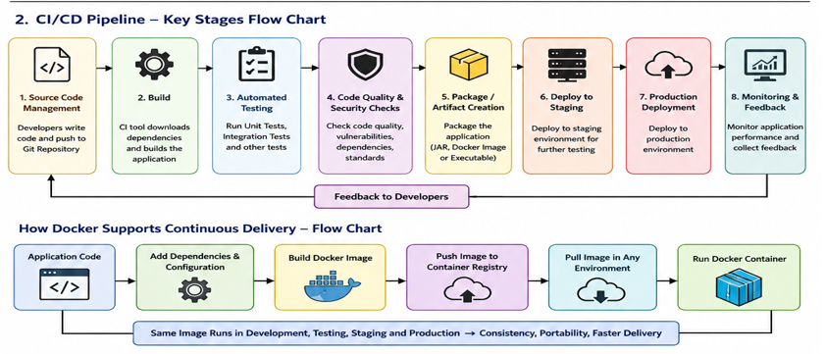

Conclusion: CI/CD automates the software delivery process, while Docker provides a consistent and portable environment. Together, they enable faster, reliable, and repeatable software delivery.

3. Case Study – Intermittent Slowdowns in a Large SaaS Application
A large SaaS application experiences intermittent slowdowns, meaning the application is normally fast but occasionally becomes slow. Monitoring and logging tools can help identify the exact cause.

1. Prometheus – Metrics Collection
Prometheus collects and stores numerical metrics from applications and infrastructure.
It can monitor:
- CPU utilization
- Memory usage
- Request rate
- Response time
- Error rate
- Database performance
- Network traffic
Application → Metrics → Prometheus → Time-Series Database
If response time suddenly increases from 200 ms to 5 seconds, Prometheus can record this change. It can also generate alerts when a metric crosses a defined threshold.

2. Grafana – Visualization and Monitoring
Grafana provides dashboards for visualizing metrics collected by Prometheus.
Example dashboard indicators: CPU Usage = 90%, Memory Usage = 70%, Response Time = 4.8 seconds, Error Rate = 3%.
Grafana helps administrators quickly identify when and where a slowdown occurs.
- High CPU → possible overloaded server.
- High memory → possible memory leak.
- High response time → slow application or database.
- High error rate → application or service failure.

3. ELK Stack – Log Analysis
The ELK Stack consists of Elasticsearch, Logstash, and Kibana.
Elasticsearch – Stores and searches logs.
Logstash – Collects and processes logs.
Kibana – Visualizes and analyzes logs.
Application Logs → Logstash → Elasticsearch → Kibana
Logs may contain:
- Timestamp
- User request
- API endpoint
- Response time
- Error message
- Database query
- Server information

How These Tools Work Together
Tool | Main Function | Example
Prometheus | Collects metrics | CPU, memory, response time
Grafana | Visualizes metrics | Performance dashboards
ELK Stack | Analyzes logs | Errors and slow requests

Detecting the Problem
Prometheus detects that response time has increased.

Diagnosing the Problem
Grafana helps identify the affected server or service by comparing CPU, memory, request rate, and response-time metrics. ELK can then be used to examine application logs and find the specific error, API request, or database operation causing the slowdown.

Resolving the Problem
- Optimize slow database queries.
- Increase server resources.
- Fix application bugs.
- Correct memory leaks.
- Improve caching.
- Scale services horizontally.
- Optimize API calls.
After the fix, Prometheus and Grafana can verify whether response times and error rates have returned to normal.

Overall Monitoring Process

Application → Metrics → Prometheus → Grafana
Application → Logs → Logstash → Elasticsearch → Kibana
Detect Problem → Diagnose Root Cause → Fix Problem → Monitor Again

FLOW CHART
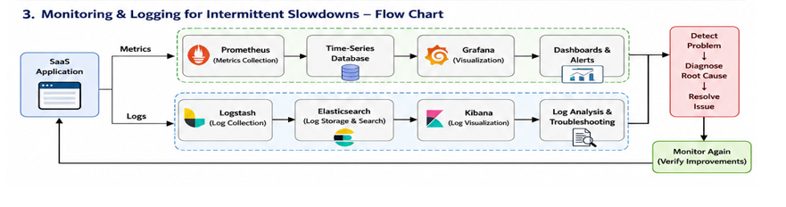
Conclusion: Prometheus provides the metrics, Grafana provides visual monitoring, and the ELK Stack provides detailed log analysis. Using them together allows a SaaS team to quickly detect intermittent slowdowns, identify their root causes, resolve them, and continuously verify application performance.

